Home page

Login Page

Register page

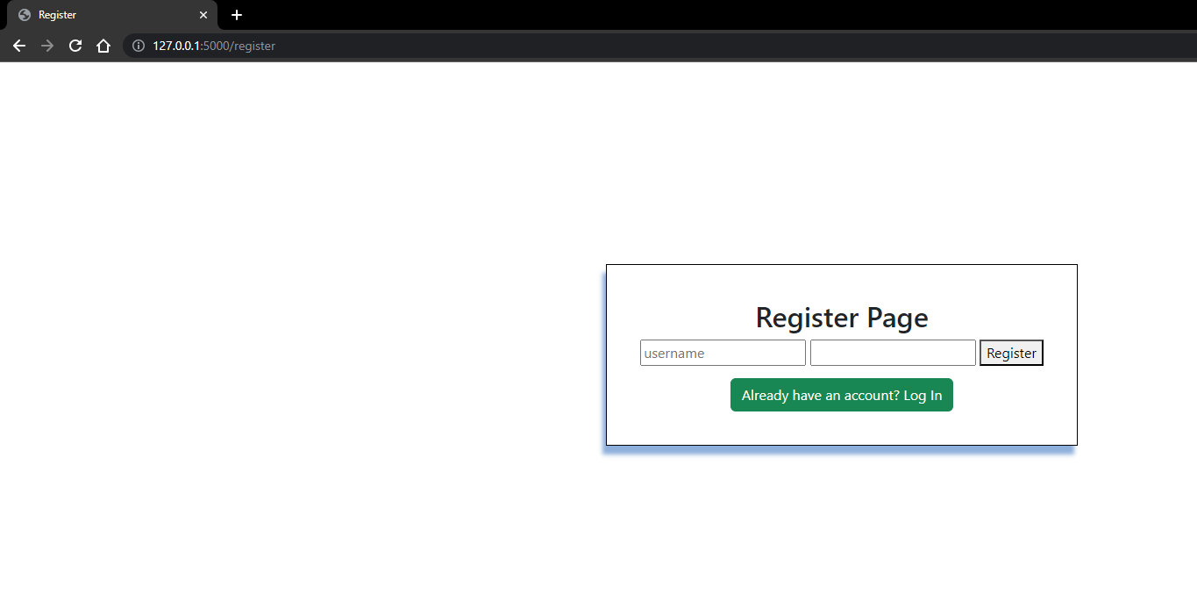

Database Table data

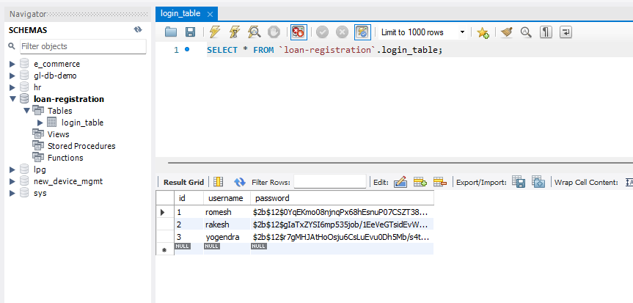

Registering new user

New User in database Table

After login and register – enter-details screen

Enter-details screen with details.

After submitting the details i.e predict screen

